
24th Oct 2018
Attn : Roz
Email : roz.tang@rentokil-initial.com

Project Location
Level 5 Changi South Lane

Birds Founds
- Pigeon
Clean up and Sanitization
There are over 40 known viruses and 60 transmittable diseases that are directly attributable to birds and their fecal matter. Also, birds carry up to 10 parasites on their legs, wings and bodies, and these usually co-exist in bird nests that are active. Due to these hygiene hazards, we recommend that the areas of this bird abatement program be sanitized and cleaned prior to any controls being installed. This protects not only our workers, but also our customers and their property/visitors.
The clean-up is not substantial and as such, there is very little allowance for costs. However, sanitation is always a part of our bid.
Problem and Purpose
The client is facing problems with pigeons flying in to the warehouse. The purpose of this project is to minimize the areas where the birds usually perch. This installation will prevent the birds from entering the premises to roost/nest.

Sliding Netting
This project requires the help of invisinet with chain on the bottom. The netting will be installed on the area as mention in the proposal below:-
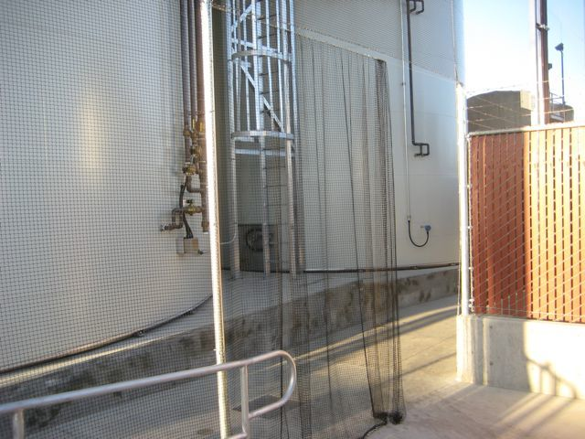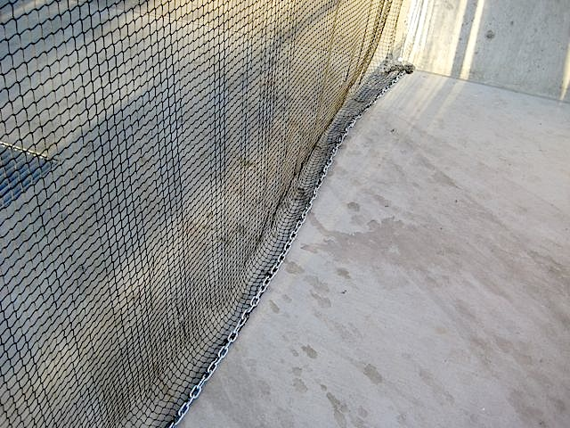

Invisinet Knotless sliding netting installation
The installation will prevent birds from flying into the premises to roost/nest. ¾” black netting will be used for the installation.

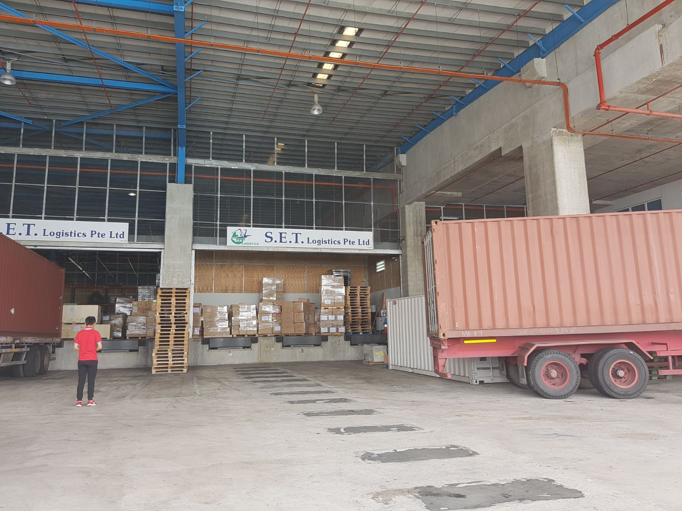
Figure 1: Install sliding net on the 2 doors and metal chain on the bottom of the net

Figure 2: Install sliding net at the side door and metal chain on the bottom of the net

Job Scope
HotFoot Asia will begin the work by drill the wall plug and run the stainless steel wire. We do not provide cleaning due to the installation near to the cable tray and electricity wire.
Quote
We offer to quote for the birds control services.
Location | Price
Sliding net (2 big doors and 1 small door) | $4,300.00
Lifting equipment | $1,000.00
Total | $5,300.00

- We require an estimation of 2 working days to complete this installation (Mon-Fri 9am - 6pm)
- Lifting equipment/working platform will provide by Hotfoot Asia Pte Ltd.
- Quote valid for 30 days from quotation date.
- Guarantee does not cover bird migratory to/bird entry from other areas within the premises that are not bird-proofed by Hotfoot Asia.
- Price exclusive of 7% GST.
- If there are blinded spot areas which were not spotted from the initial survey or quotation sent to client and additional materials are required in actual day Hotfoot Asia will only do additional blind spots jobs and billed accordingly after client’s consent.
- Please choose netting colour either Black/Stone.

Terms and Conditions
This quote is based on the following terms and conditions:
- Price is quoted in Singapore dollar.

- We request 30% of the contract sum as down payment upon awarding the project and balance 70% upon job hand over.
- We require a minimum of 14 business days to schedule the work once it is awarded. If a customer requests that the work commence less than 7 business days from the date the work is awarded and express shipment of materials is required, additional freight charges may be levied to the invoice to cover these costs.
- If a certificate of insurance is required specifying “additionally insured” or a certificate with special wording, an additional $400 will be added to the final invoice. If any modifications to our existing insurance certificate are required then the cost of these additions would be added to the quote.
- Once a job has begun, if it is delayed for reasons not under the control of HotFoot Asia Pte Ltd, any additional boom rental and the associated pick-up and delivery charges will be added to our final invoice. Crew downtime, travel, and expense charges based on this delay will be charged $220 per hour. We will advise the customer of any incremental charges based on delays before work recommences.
- All contents in this document are intellectual properties belonging to Hotfoot Asia Pte Ltd, and we reserve the right to claim for damages against any misuse, duplication or distribution.
Acknowledged by: Quotation accepted by:
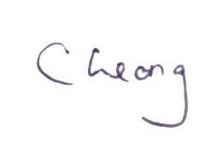 __________________________
HotFoot Asia Pte Ltd Name:
Date: Date:
Company Chop:
Service Warranty

Our service warranty offers comprehensive guarantees on all its products to protect its customers against failure caused by faulty workmanship.
Installations organized by Hot Foot Asia Pte Ltd carry a 2-years guarantee, excluding access equipment costs.
Guarantees for Hot Foot products are excluded from damage caused by deliberate abuse, vandalism, storms, ice, snow and other “acts of God”. They are not warranted if corrosive materials are applied to the products or if their factory supplied finish is altered or coated by such activities as painting, as these can be corrosive to the material from which our product are made.
Application of Hotfoot/PCS Gel is not covered under our warranty. This is due to the fact that when birds are deterred by the gel, their feet will pick up/smear some of the gel and therefore, the product will diminish over time. Clients are well-informed that such bird control measures are not ideal for heavy-pressured areas.
Product Warranty

HOT FOOT INVIST-NETTM
In addition to the statements made in our warranty overview, Hot Foot Asia Pte Ltd guarantees its knotless Invisit-Net for a period of 10 years from the date of installation subject to the following terms:
- Invisi-Net is not guaranteed against damage caused by deliberate abuse, by foreign material (paint, etc.), by pets such as rodents and squirrels, or by chemicals that are corrosive to the net material (polypropylene) being applied to it.
- Invisi-Net knotless netting will melt if placed too close to surfaces heated above the melting point og the net (275 degrees F). Knotted nets will melt at approx. 230 degrees F.
- The Invisi-Net application must not be tampered with after a qualified technician has completed the application.
- All complaints must be accompanied by the original invoice showing proof of purchase and purchase date.

Portfolio
Singapore Projects
- SMRT Corporation Ltd – MRT Stations
Installation of netting on beams found at the platform.
- Overseas Family School
Re-installation of netting to deter birds at swimming pool.
- PSA Tanjong Pagar
Installation of netting, repellent gel and bird spikes for bird deterrent
- Singapore Powergrid
Installation of netting over generators.
- Micron Semiconductor Asia Pte Ltd
Installation of netting along the loading bay
- Singapore Hotel Associates
Installation of netting and spikes on the exterior of the building.
- Jotun (Singapore) Pte Ltd
Installation of netting in the warehouse, spikes installation on pillars.

Please feel welcomed to contact us for further clarifications.

